Y I
T
S
_{O}F TH_{E}
P
H
I
L
_{CHINERY} TESTIN_{G AND EVA}
R
^{N}U ^{V}I ^{E}
¹⁹0 8
1977
P^{I P} N^{I E}S
A
M
L
A
R
U
^{G}A ^{R C}I ^{ULT}
L
U
T
A
O^{I}
N
^{CENT} R^{E}
TEST REPORT NO. 2013 - 142
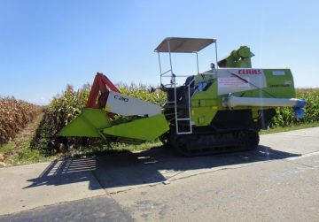
CLAAS Corn Combine Harvester (B)
Model: Crop Tiger 30 Tiera Tract
College of Engineering and Agro-Industrial Technology University of the Philippines Los Baños,
College, Laguna, 4031 Philippines
Tel/Fax No. (049) 536-2527 e-mail: amtec@uplb.edu.ph http.//amtec.uplb.edu.ph
CLAAS CROP TIGER 30 TERRA TRAC MULTI-CROP COMBINE HARVESTER (tested for Corn) - B
Test Report No. : 2013 - 142
Date of Test : March 13, 2013
Test Valid Until : March 13, 2018
Brand : CLAAS
Model : CROP-TIGER 30 TERRA TRACT Type : Ride-on, crawler-type, tank-type Manufacturer : CLAAS INDIA PRIVATE, LTD.
Test Requested By : AGRI COMPONENT CORPORATION National Highway, Tagaran
Cauayan City, Isabela
Machine Classification : Commercial
SUMMARY
The CLAAS Crop Tiger 30 Terra Trac Multi-Crop Combine Harvester was tested using Dekalb 9132 corn variety with a Grain Moisture Content of 25.6%, wet basis, Corn Kernel-Corn Ear Ratio of 0.80 and average Plant Height of 2540 mm. This was the second test for the same corn combine harvester requested by the same company. The first test was conducted on September 8, 2012 with Test Report No. 2012-246.
Based on the results of the test, the CLAAS Crop Tiger 30 Terra Trac Multi Crop Combine Harvester had an Actual Field Capacity of 0.391 ha/h or 2.56 h/ha and Field Efficiency of 77.6% at an average Travelling Speed of 2.84 kph. It had also a Shelled Grain Output Capacity of 3861 kg/h with shelled grain Purity of 98.26%. The corn combine harvester had a Total Grain Loss of 9.33% consisting of 8.86% Unpicked Loss, 0.02% Blower Loss, 0.30% Separation Loss, 0.15% Unshelled Loss and no Uncut Loss.
CLAAS Crop Tiger 30 Terra Trac Multi-Crop Combine Harvester (tested
2
for Corn) - B……
Grain quality analysis of threshed grains showed a net percent Cracked Grain of 5.33 % and Broken Grains of 1.94%
The Fuel Consumption Rate of the corn combine’s 44.2 kW diesel engine was 5.77 L/h.
During the test, three persons were needed to operate the corn combine: one for operating the machine and two for bagging.
No breakdown or failure of components occurred during the test.
PURPOSE AND SCOPE OF TEST
The machine was tested for verification of its performance. The test was conducted at a farmer’s field in Brgy. Villa Luna, Cauayan City, on March 13, 2013 and was evaluated on the following items:
1. Actual Field Capacity
2. Field Efficiency
3. Output Capacity
4. Grain losses
a. Unpicked Loss
b. Separation Loss
c. Blower Loss
d. Uncut Loss
e. Unshelled Loss
5. Fuel Consumption
OPERATOR’S MANUAL
The operator’s manual submitted with the machine contains the following: Key Points of Safe Operation; Safety Signs and Positions to be Posted; Position and Functions of Each Unit; Check Before Operation; Travel and Transportation; Method of Harvesting; Maintenance; General Faults and Solutions; Technical Specifications; and, After Sales Services.
CLAAS Crop Tiger 30 Terra Trac Multi-Crop Combine Harvester (tested
3
for Corn) - B……
DESCRIPTION OF THE MACHINE
The CLAAS Crop-Tiger 30 Terra Trac Multi-Crop Combine Harvester (Figure 1), was a ride-on, crawler-type, tank-type harvesting machine which combined the cutting and shelling operations in one machine. It was powered by a diesel engine which drove the transmission systems of the machine. The corn combine consisted of reel assembly, cutting assembly, screw and chain conveyors, shelling assembly, traveling device and control levers.
The reel assembly (Figure 2) with its rotary motion guides the corn plant to the cutting assembly. It consisted of five anchor bars.
The machine’s cutting device consisted of reciprocating cutting knives (Figure 3). It had a cutting width of 2.0 m and the height of cut was adjustable. The corn combine’s delivery device to its shelling unit consisted of a screw conveyor (Figure 4a) and a chain conveyor (Figure 4b). The screw conveyor conveyed the cut plants to a chain conveyor which in turn delivered the cut plants to the shelling chamber of the combine.
The shelling assembly was an axial-flow type and consisted of an open-type cylinder.
The cleaning assembly consisted of a centrifugal fan which separated the small corn cobs and other light impurities from the shelled grain and a double layer oscillating screen.
CLAAS Crop Tiger 30 Terra Trac Multi-Crop Combine Harvester (tested
4
for Corn) - B……
The corn combine was provided with a grain tank (Figure 5) which held the shelled grain and a folding-type discharge chute (Figure 6) with screw conveyor where shelled grains were discharged.
The corn combine harvester was provided with control levers and control panel (Figure 7). The control levers were the following: accelerator lever; shelling clutch lever, main shift lever; reel lifting lever; and, steering and cutting table operating lever. The control panel houses the speedometer and pilot lights for water temperature, oil pressure, and battery charge.
The machine had a crawler-type (Figure 8) traveling device.
CLAAS Crop Tiger 30 Terra Trac Multi-Crop Combine Harvester (tested
5
for Corn) - B……
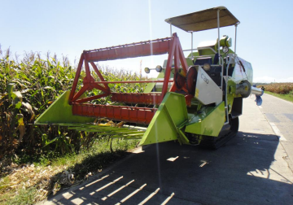
Figure 1. CLAAS Multi-Crop Combine Harvester
Model: Crop-Tiger 30 Terra Trac
CLAAS Crop Tiger 30 Terra Trac Multi-Crop Combine Harvester (tested
6
for Corn) - B……
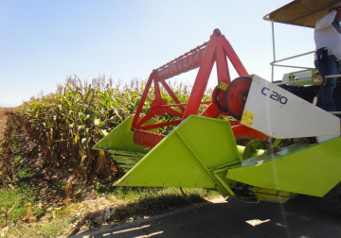Figure 2. Reel Assembly
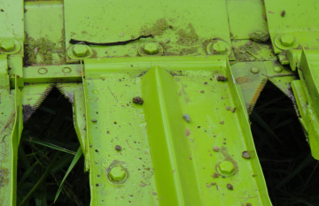Figure 3. Reciprocating cutting knife
CLAAS Crop Tiger 30 Terra Trac Multi-Crop Combine Harvester (tested
7
for Corn) - B……
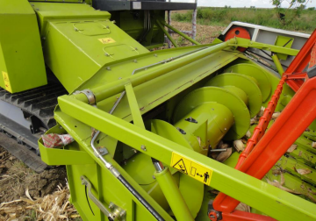

Figure 4. a) Screw conveyor
b) Chain conveyor

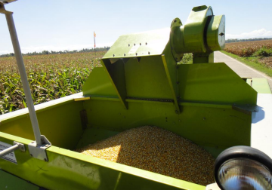Figure 5. Grain Tank

CLAAS Crop Tiger 30 Terra Trac Multi-Crop Combine Harvester (tested
8
for Corn) - B……
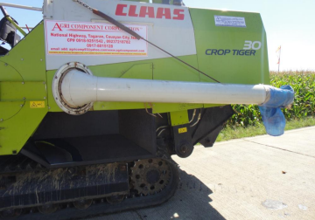Figure 6. Folding-type discharge chute with
screw conveyor
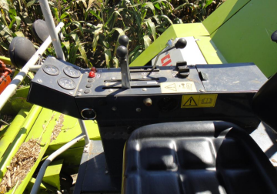Figure 7. Control levers and control panel
CLAAS Crop Tiger 30 Terra Trac Multi-Crop Combine Harvester (tested
9
for Corn) - B……
Figure 8. Crawler-type traveling device
CLAAS Crop Tiger 30 Terra Trac Multi-Crop Combine Harvester (tested
10
for Corn) - B……
RESULTS AND DISCUSSIONS
Results of field performance tests are shown in Table 2.
Performance
The performance of the corn combine was evaluated in terms of its field capacity, field efficiency, output capacity, grain losses and grain quality. Actual Field Capacity. It is the ratio of the area harvested and the total time of operation. The Actual Field Capacity of the machine was 0.391 ha/h or 2.56 h/ha. Field Efficiency. It is the ratio of the Actual Field Capacity and the Theoretical Field Capacity, expressed in percent. Based on the Theoretical Field Capacity of 0.504 ha/h, the Field Efficiency of the machine was 77.6%.
Unpicked Loss. This refers to the kernels of the corn ears that have fallen to the ground during the machine’s cutting operation. Unpicked Loss was 8.86%. Separation Loss. This refers to the grains that come out of the shelling chamber with the cut plants. Separation Loss was 0.30%.
Blower Loss. This refers to the grains that come out of from the blower outlet. Blower Loss was 0.02%.
Uncut Loss. This refers to the kernels of the corn ears from the corn plant that were not cut or missed by the reaping mechanism of the machine. There was no Uncut Loss.
Unshelled Loss. This refers to grains that remained on the corn ears fed into the shelling chamber. Unshelled Loss was 0.15%.
CLAAS Crop Tiger 30 Terra Trac Multi-Crop Combine Harvester (tested
11
for Corn) - B……
Grain quality. Quality of shelled grain was determined in terms of percent cracked and broken grains. Results showed that the shelled output had a net percentage Cracked Grains of 5.33 % and Broken Grains of 1.94 %. (Cracked grains Refer to those grains whose endosperms are partially fractured while broken grains refer to those grains that are split into 2 or more pieces.)
Fuel Consumption
The corn combine’s diesel engine had a Fuel Consumption Rate of 5.77 L/h.
Labor Requirement
Three persons were needed during operation of the corn combine (Figure 9): one for operating the machine and two for bagging.
Observations
1. The corn combine was provided with an operator seat (Figure 10a) and a canopy (Figure 10b) for the convenience of the operator.
2. The corn combine was easy to maneuver at corners (Figure 11). 3. When the grain tank was full, shelled grains were discharged through the folding-type discharge chute (Figure 12) with screw conveyor.
4. The corn combine was provided with stickers (Figure 13) on safety.
CLAAS Crop Tiger 30 Terra Trac Multi-Crop Combine Harvester (tested
12
for Corn) - B……
a) Machine operator
b) Baggers
Figure 9. Labor requirements during machine operation
CLAAS Crop Tiger 30 Terra Trac Multi-Crop Combine Harvester (tested
13
for Corn) - B……
Figure 10. a) Operator’s seat
b) Canopy
Figure 11. Turning at corner
CLAAS Crop Tiger 30 Terra Trac Multi-Crop Combine Harvester (tested
14
for Corn) - B……
Figure 12. Discharge of shelled grains
Figure 13. Sticker attached to the corn combine
CLAAS Crop Tiger 30 Terra Trac Multi-Crop Combine Harvester (tested
15
for Corn) - B……
FIELD PERFORMANCE TEST
Machine tested : CLAAS Multi-Crop Combine Harvester
(tested for Corn) - B
Model : Crop Tiger 30 Terra Tract
Location of test: Brgy. Villa Luna
Cauayan City
Date of test : March 13, 2012
Table 2. Results of field performance test
ITEMS TEST DATA*
A. Condition of Crop
1. Variety : DEKALB 9132
2. Number of Plants/Hill : 3
3. RowSpacing (mm) : 700
4. Plant Height (mm) : 2540
5. Corn Ear Dimension, L x D (mm) : 145 x 41
6. Corn Kernel – Corn Ear Ratio : 0.80
7. Moisture Content of Grains (%) : 25.6
B. Field Conditions
1. Type of Soil : Sandy loam
2. Soil Resistance (kg/cm²) : 6.67

* Average of two test trials
CLAAS Crop Tiger 30 Terra Trac Multi-Crop Combine Harvester (tested
16
for Corn) - B……
Table 2. Results of field performance test (cont’n.)
ITEMS TEST DATA*
C. Field Performance
1. Method of Operation : Alternating Pattern 2. Travelling Speed (kph) : 2.84
3. Effective Cutting Width (mm) : 2100
4. Height of Cut (mm) : 660
5. Actual Field Capacity
a) ha/h : 0.391
b) h/ha : 2.56
6. Theoretical Field Capacity
a) ha/h : 0.504
b) h/ha : 1.98
7. Field efficiency (%) : 77.6
8. Shelled Grain Output
Capacity (kg/h) : 3861
9. Shelled grain unloading rate (kg/h) : 39808
10. Purity of shelled grain (%) : 98.26 11. Unpicked Loss (%) : 8.86
12. Blower Loss (%) : 0.02
13. Separation Loss (%) : 0.30

* Average of two test trials
CLAAS Crop Tiger 30 Terra Trac Multi-Crop Combine Harvester (tested
17
for Corn) - B……
Table 2. Results of field performance test (cont’n.)
ITEMS TEST DATA*
14. Unshelled Loss (%) : 0.15
15. Uncut Loss (%) : Nil
16. Total Grain Loss (%) : 9.33
17. Noise level, db(A) : No Data
18. Fuel consumption, (L/h) : 5.77
D. Laboratory Grain Analysis
1. Before Harvest
a) Cracked (%) : 0
b) Broken (%) : 0
2. After Harvest
a) Cracked (%) : 5.33
b) Broken (%) : 1.94
3. Net Percent
a) Cracked : 5.33
b) Broken : 1.94

* Average of two test trials
CLAAS Crop Tiger 30 Terra Trac Multi-Crop Combine Harvester (tested
18
for Corn) - B……
Test Engineer:
________________________
DARWIN C. ARANGUREN
Checked by:
____________________
ROMULO E. EUSEBIO
Approved for release:
___________________________
DELFIN C. SUMINISTRADO
Director
_______________________
Date
N.B.
This test report should not be used for advertisement or for promotion of the product but only for evaluation purposes and should not be reproduced in whole or in part without permission of AMTEC.

